**Roaming in Japan-**

**Entirely enchanted by the modern and ancient scenery**

Human activities do make changes to the original appearance of a place. For the sake of pursuing better living environments, the Japanese emphasize on the neatness and comfort of their home. Consequently, there is well-balanced between the conservation and development. During our travelling, we were all impressed by the fusion of the modern and ancient scenery in Kyoto and Osaka.

On the second day of our trip, we went to Kyoto, a historical city. The city is formed by mainly two-storey buildings and traditional temples. Most of the buildings are well-preserved. The most representative downtown is Gion. A lot of old-style Japanese houses and machiya still exist. Part of the district has been declared a national historical preservation district. Walking down the street in Gion, you can see that there are all wooden buildings on both sides. All the things make us feel like we are people from the past and it helps us know more about Japanese culture easily.

The night view of Gion is great. Along the river, there are willows planted along the riverbank. Also, the traditional wooden teahouses and restaurants on both sides of the river light up their lanterns which also creates a fantastic night view. With the stunning street performance of a Japanese musician, it forms a beautiful picture at night.

In addition, we visited Kyoto University and had an enjoyable lunch there. Kyoto University is the second oldest research university in Japan. Nowadays, it has transformed into a modern academic campus. Clock Tower is the well-known symbol of the school. The clock records the most accurate time in Japan according to Greenwich Mean Time. The students love discussing and gathering in front of the Clock Tower. During our visit, some were reading while some were practicing rope skipping. We were impressed by the enthusiastic study environment that the students could do the things freely inside the university. Staying in the campus, we got in touch with the Japanese learning environment for the first time. It was one of the most special modern sceneries we saw.

On the third day, we fulfilled our wishes of shopping in Osaka. We went to Shinsaibashi , the center selling trendy japans goods. There are many advertisement boards. One of the advertisement boards even becomes the landmark of Shinsaibashi. It reflects the active commercial activities in Osaka. This drives us to another point about globalization. More than two hundred shops were located, there included many international chain stores such as Starbucks and forever 21. We spent around three hours there and it was bustling all the time. We entirely felt the prosperity of Japan in such a busy district, which was totally different from the ancient scenery we saw in Kyoto.

On the fourth day, we drove back to Kyoto and stopped at some harmonious and splendid scenic spots. We visited Sagano, a national park in Kyoto, and the heritage of Uji. It was so peaceful there in the country. There was general summer breeze when we were walking along the river. Surrounded by peaceful atmosphere, we all felt relaxed . We found a few retirees were playing Othello in the shade. They smiled in a friendly way. We made a nice conversation using English. They said they were pleased because we were fascinated by the gorgeous views of their living area.

Japan always attracts the tourists all over the world by their charming scenery. Through this travelling, we really appreciate the modern development of trendy zones and good studying environment and the well preservation of ancient cultural heritage in Kyoto and Osaka.

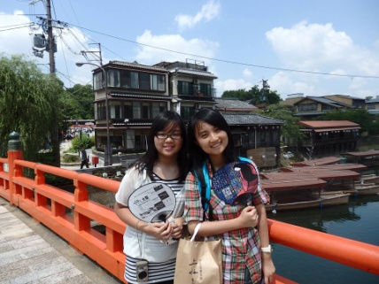  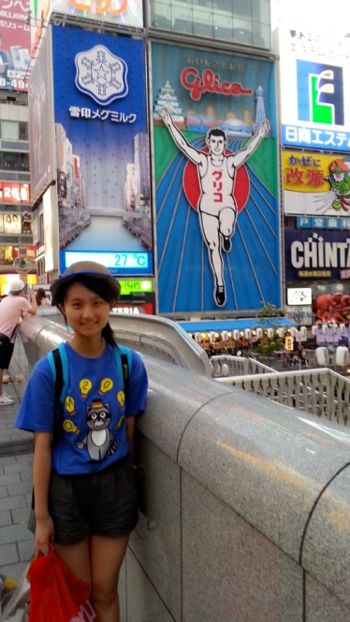 Yuen Ka Wai (5E) Law Man Yu(5E)